**Experiment No. 2**

**Bus Topology:**

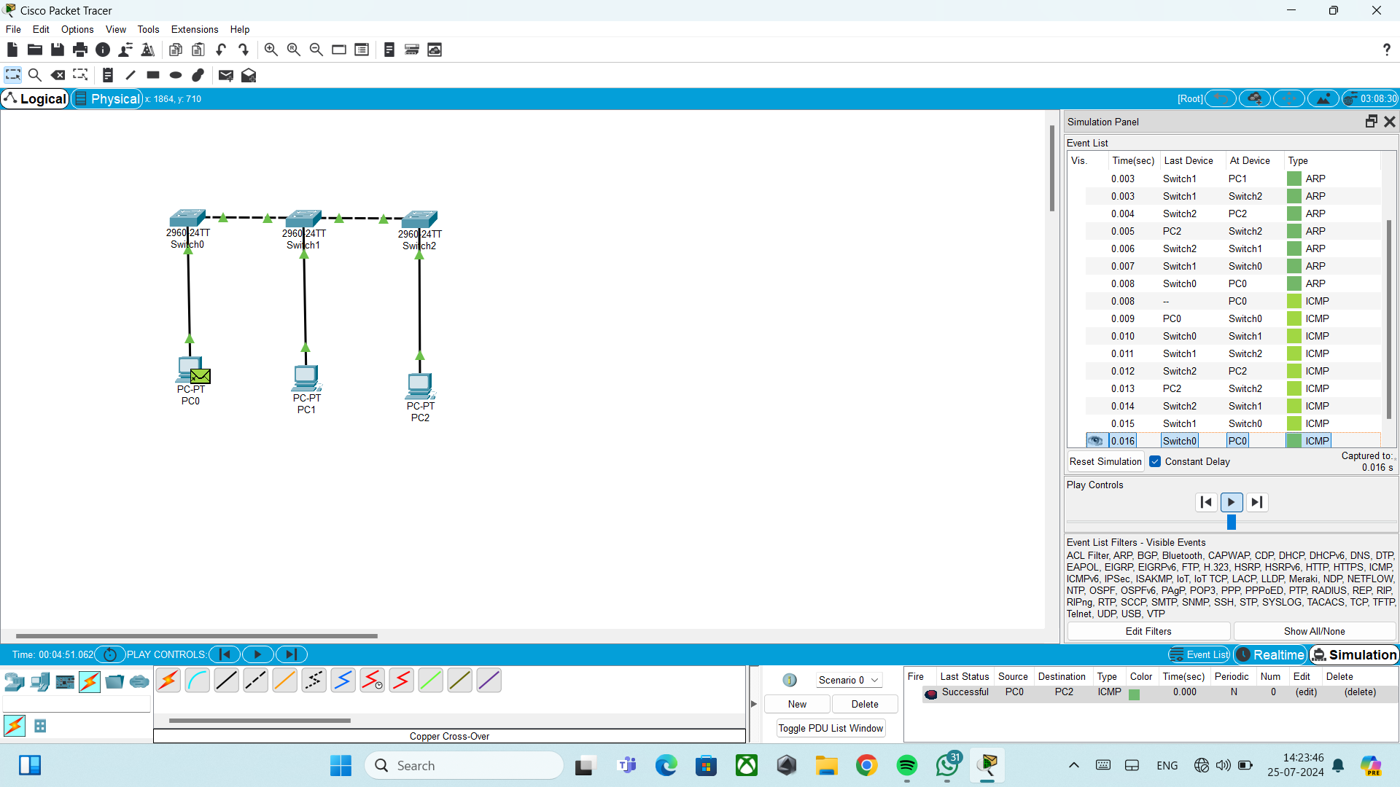

**Ring Topology:**

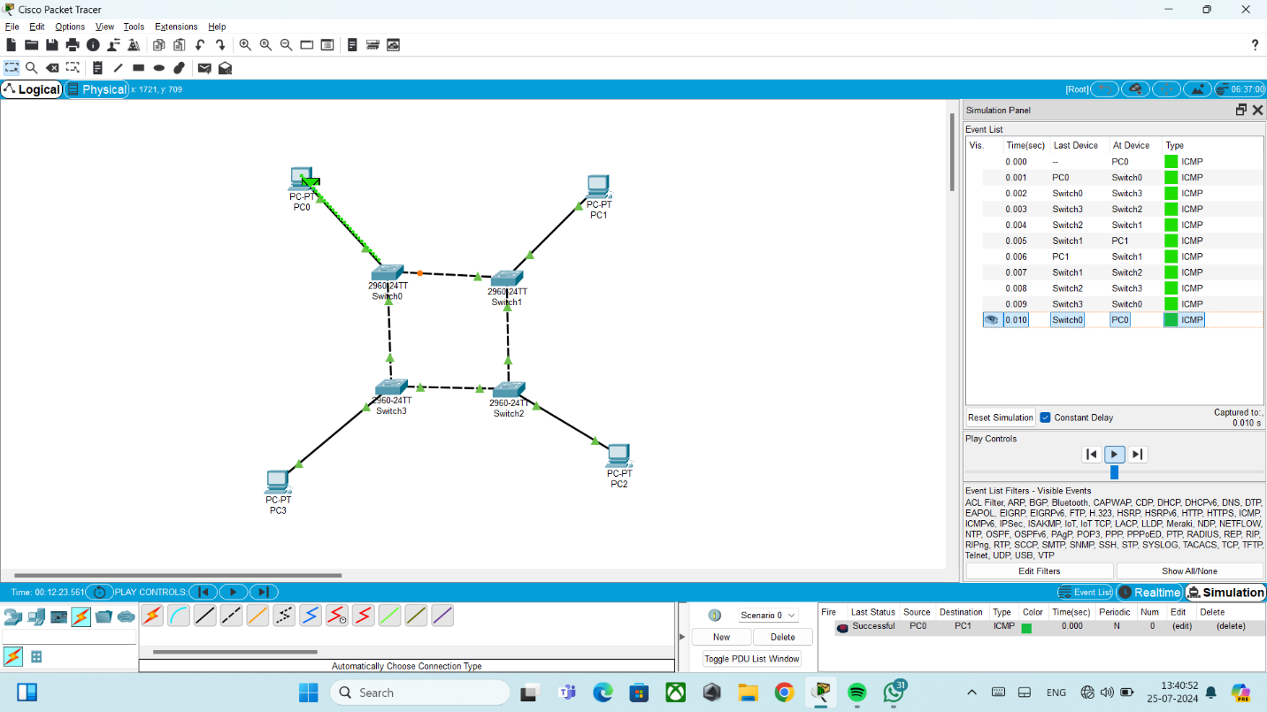

**Star Topology:**

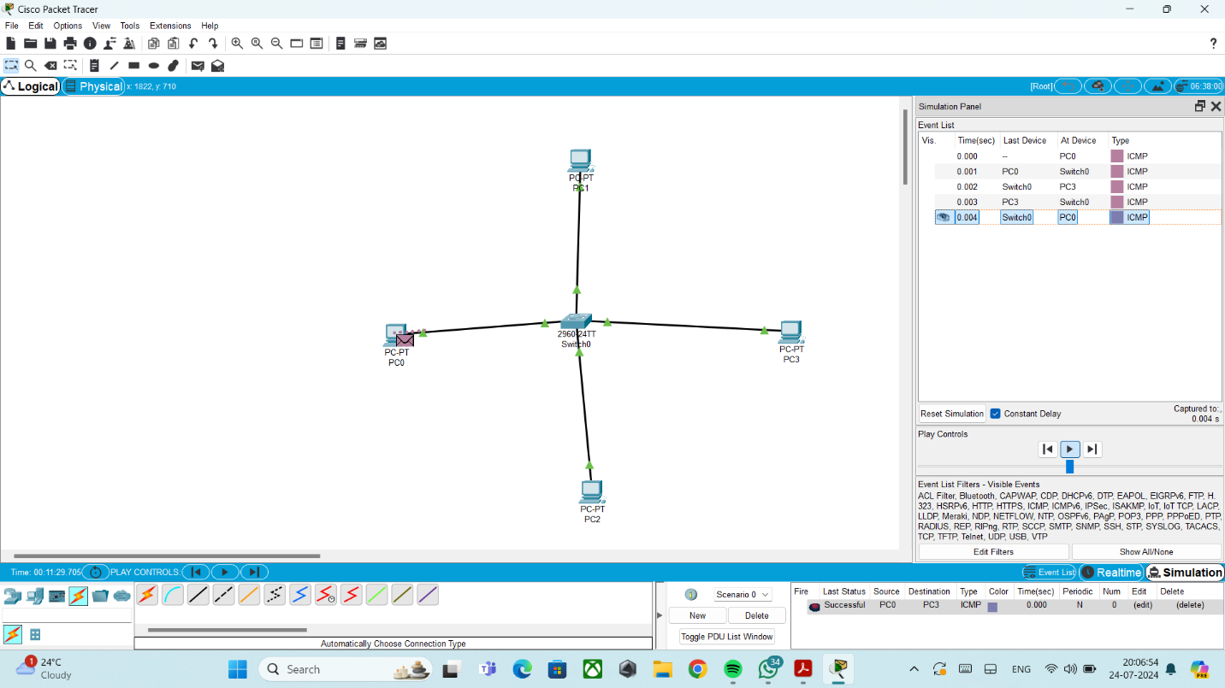

**Mesh Topology:**

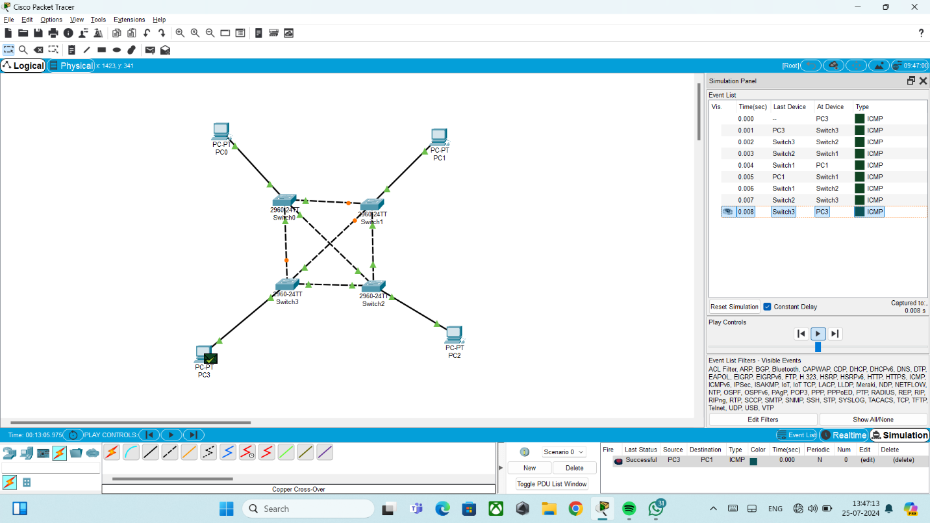

**Case Study:**

**Static Routing with 2 Router and 2 Switches:**

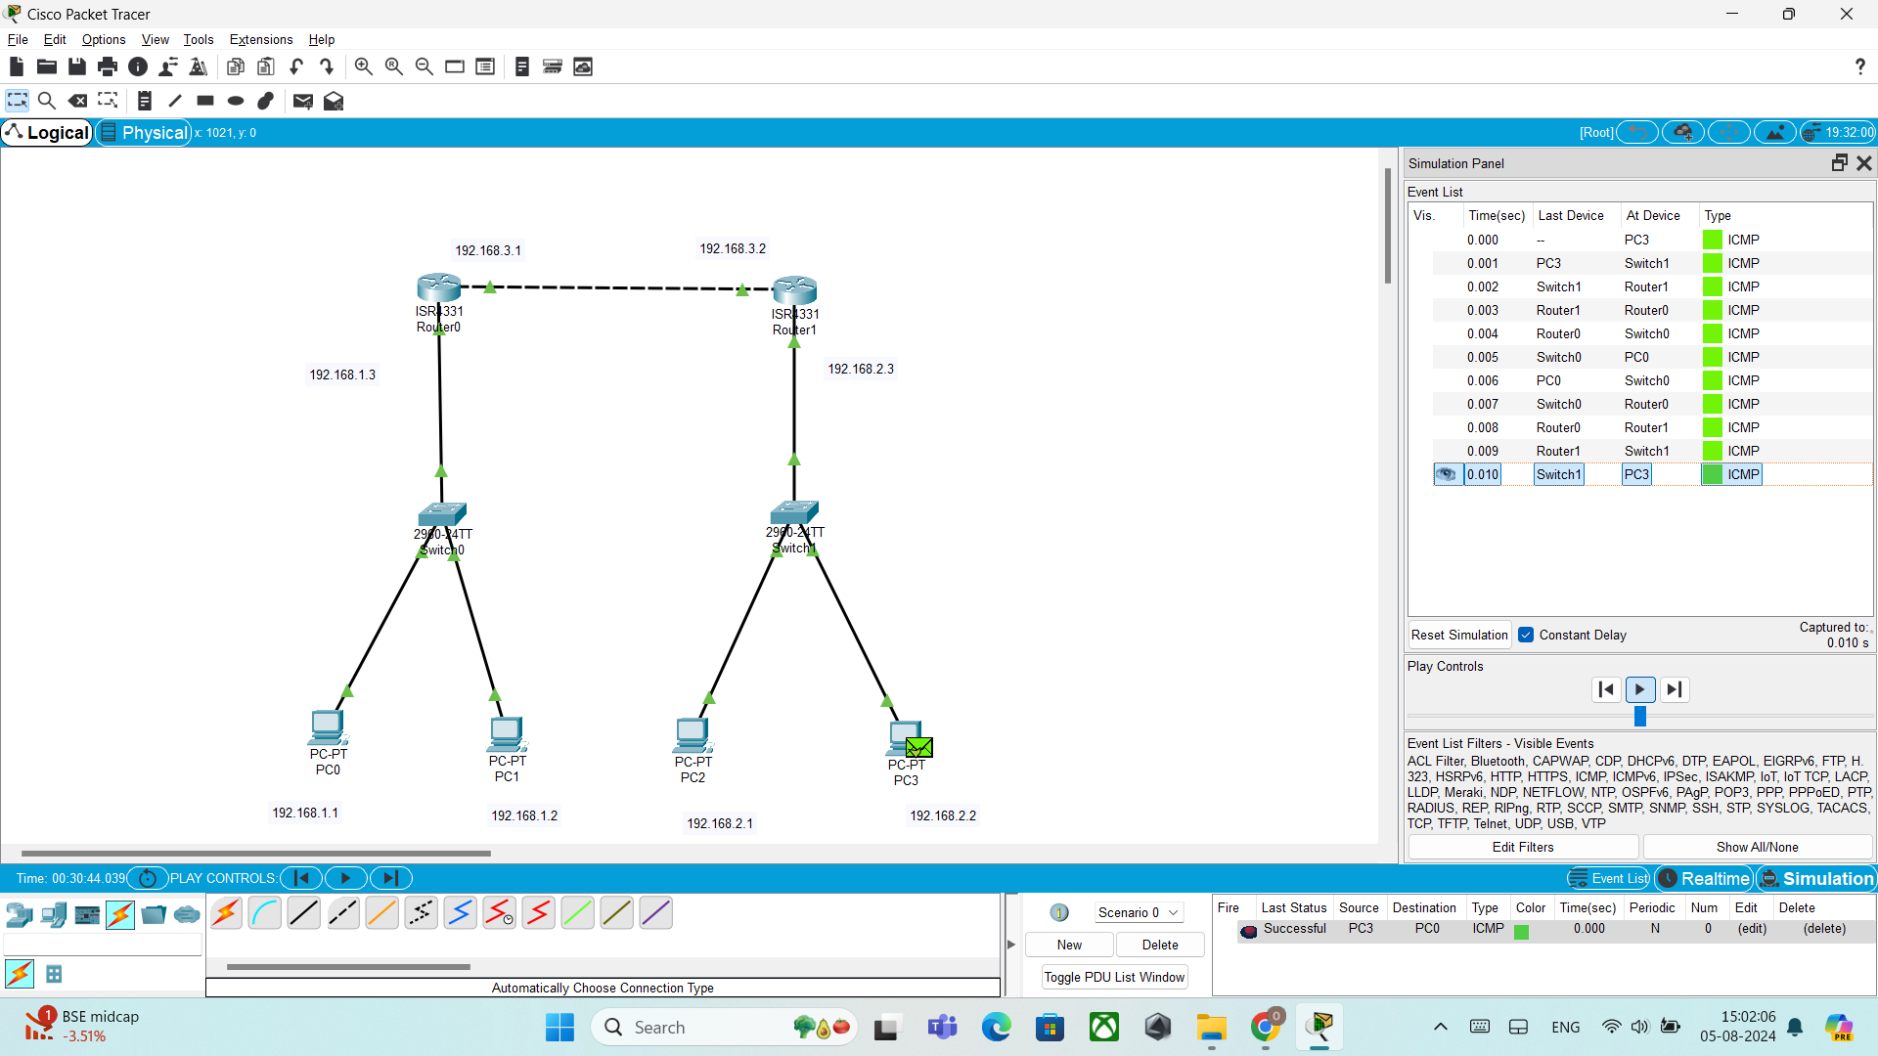

**Static Routing with 3 Router and 3 Switches:**

